WEEK 2 - Demonstrate the use of an array in a program

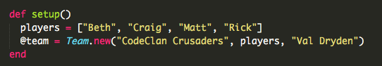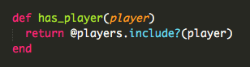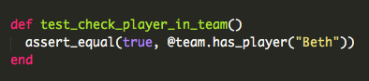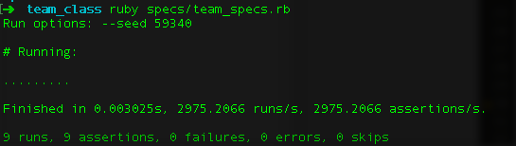

The top screenshot is showing an array of players, next is the method to check if a player is in the array then a method to test if this is true. Finally, we ran the test and it passed

WEEK 2 - Demonstrate the use of a hash in a program

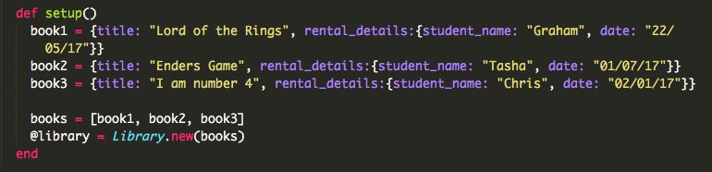

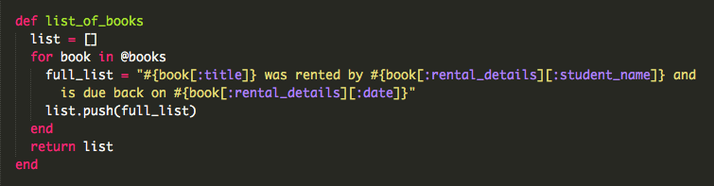

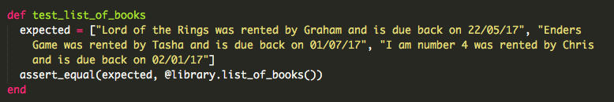

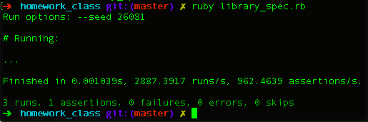

This is the same as the array in the previous page, the top screenshot is an example of a hash for each book detailing the title, rental details etc. the second is the method to call on the list of the books. The third is the test and what is expected and finally the test being run.

WEEK 3 - Demonstrate searching data in a program.



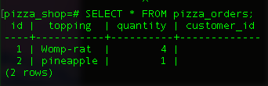

The top screenshot is showing a search on the database to show all orders. The second screenshot is the result of this query.

WEEK 3 - Demonstrate sorting data in a program.

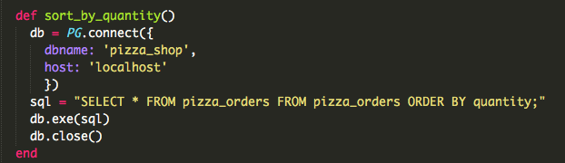

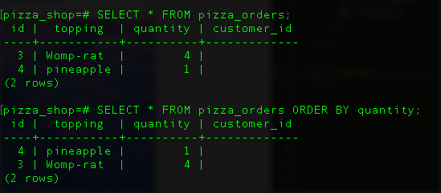

this is an example of sorting data, the top screenshot is the function to sort the info in the db and the bottom is the result of what was showing before and after the function being run

WEEK 5 - Take a screenshot of an example of pseudocode

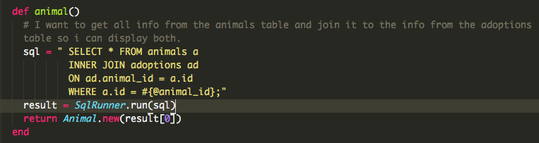

Above is an example of pseudocoding. I wrote out what I wanted to do then wrote the code to reflect this.

WEEK 5 - Show user input being processed according to design requirements.

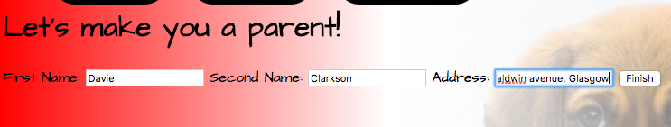

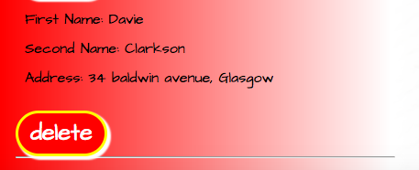

This is an example of entering a users details into the new owner section of the website and the result of it being added the bottom of the owners list.

WEEK 5 – Show an interaction with data persistence.

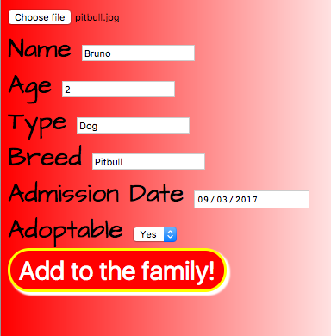

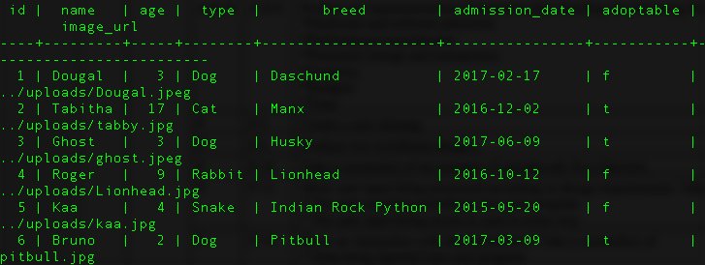

The above screenshot is showing a new animal being added to the website and the bottom image shows it being saved to the database

WEEK 5 - Show the correct output of results and feedback to user.

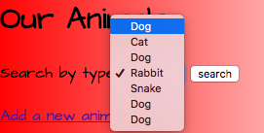

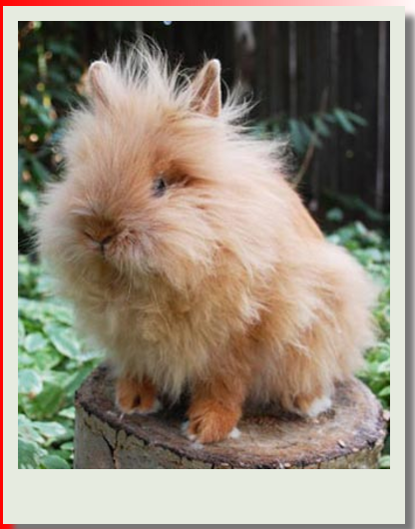

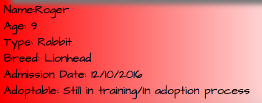

The top screenshot shows the user searching for a particular animal on the website and the bottom image is what is displayed from this result

WEEK 6 - Demonstrate the use of Polymorphism in a program.

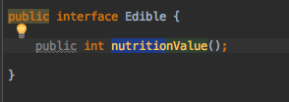 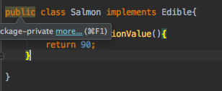

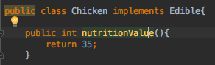

The top left screenshot is in an Interface called Edible which has the method nutritionValue. Every class that implements this Edible interface must use this method as shown in the salmon and the chicken classes but with different values.

WEEK 7 - An Inheritance Diagram

WEEK 7 - Take a screenshot of an example of encapsulation in a program.

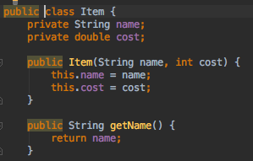

This is an example of encapsulation with in a class, the variables at the top are private but the methods are public which follow open/close principle

WEEK 7 - Take a screenshot of the use of Inheritance in a program

WEEK 7 - Take a screenshot of one of your projects where you have worked alone and attach the Github link.

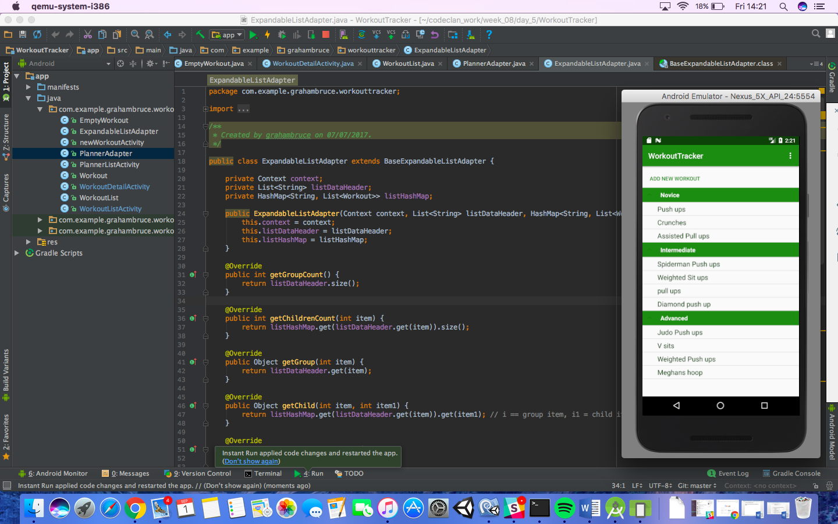

<https://github.com/GrahamBruce84/Project2-Workout-Tracker>

WEEK 7 - Take screenshots or photos of your planning and the different stages of development to show changes.

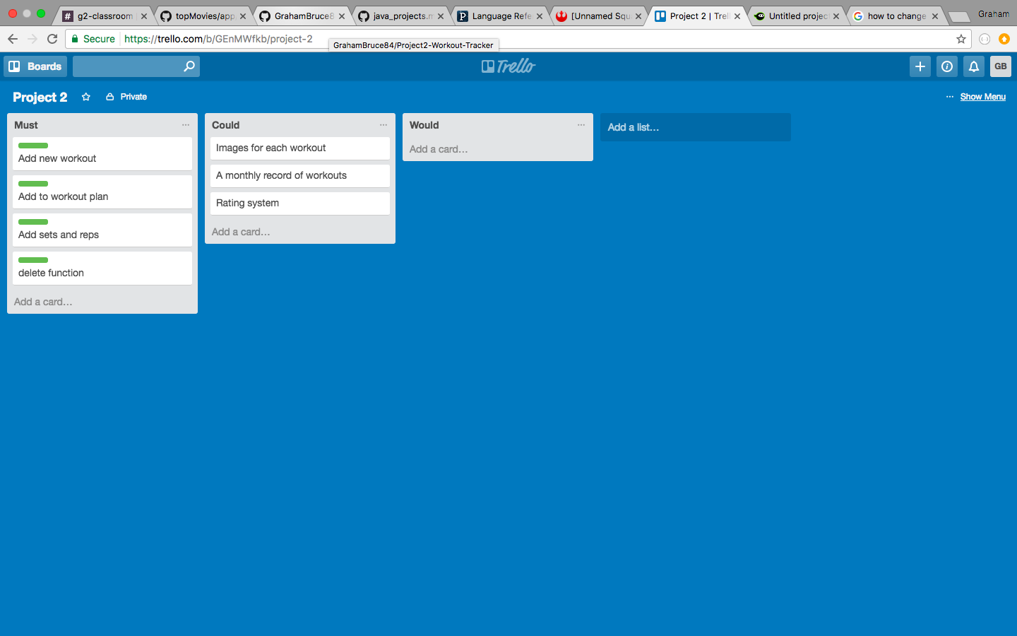

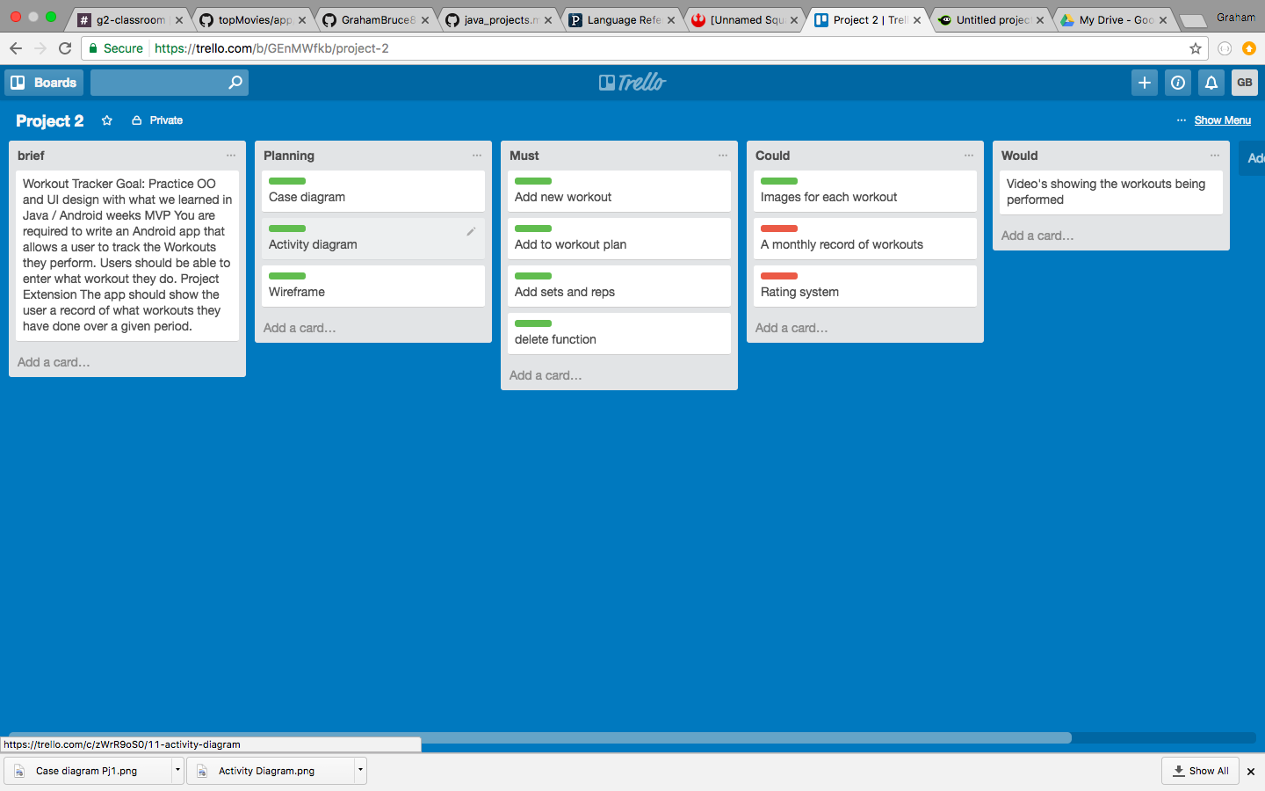

this is an example of how I started planning and what I need to have in from the beginning and then added to it as I went along

WEEK 10 - Demonstrate testing in your program

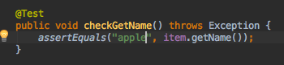

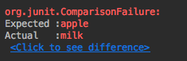

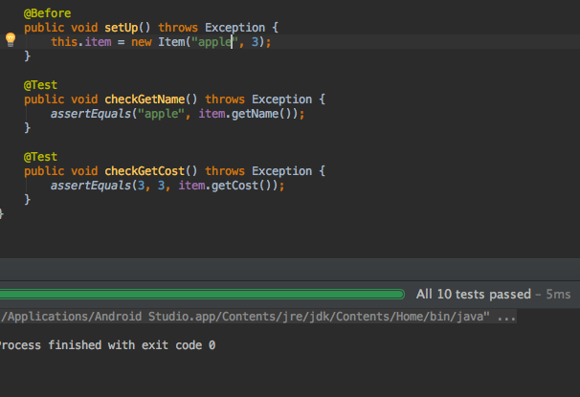

This is an example of a test running and failing then correcting the function to reflect the test and having it pass

WEEK 11 - Show an API being used within your program.

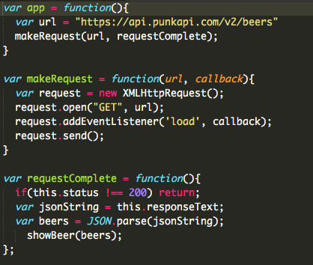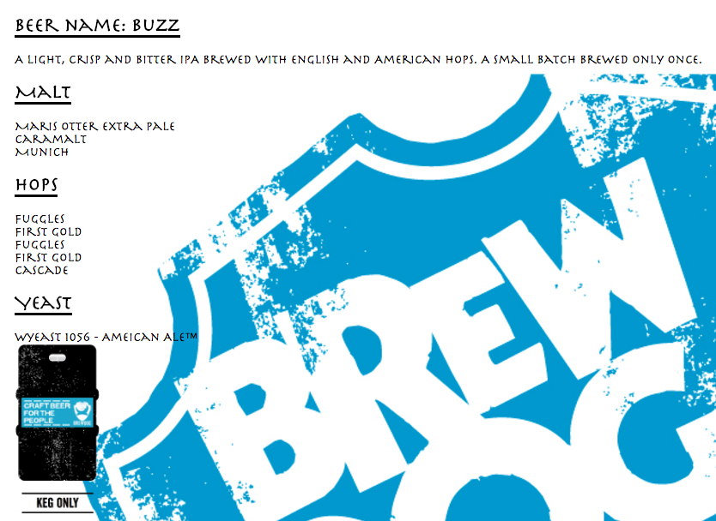

This is a function calling on the URL for the api and the then a screenshot of the website running

WEEK 13 - Take a screenshot of the contributor’s page on Github from your group project to show the team you worked with.

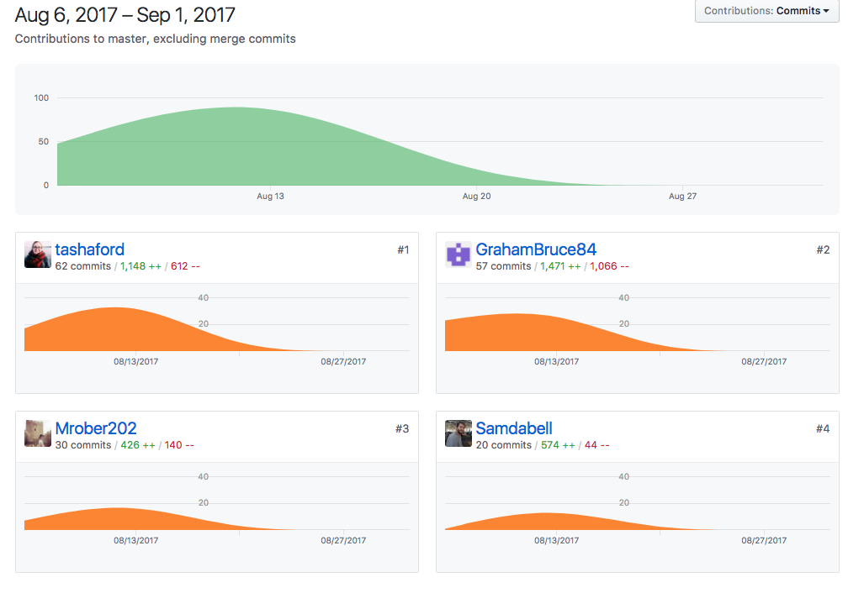

WEEK 13 - Take a screenshot of the project brief from your group project.

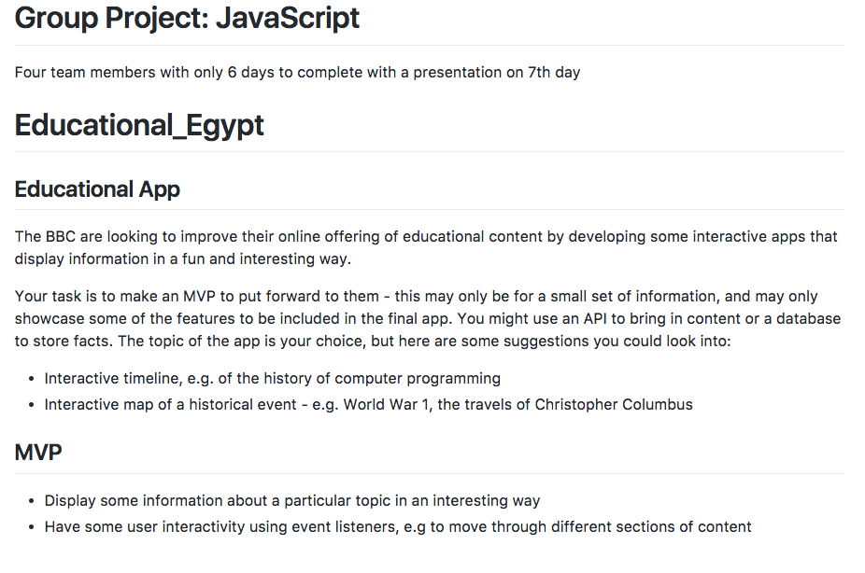

WEEK 13 - Provide a screenshot of the planning you completed during your group project, e.g. Trello MOSCOW board.

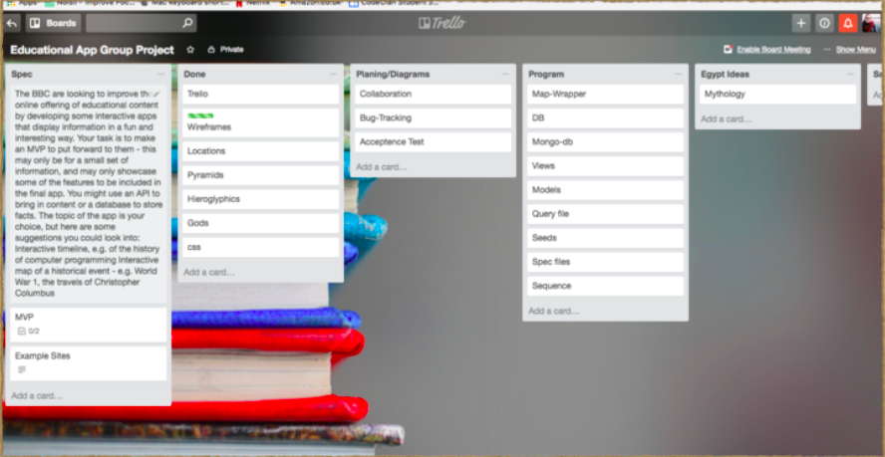

WEEK 13 - Write an acceptance criteria and test plan.

WEEK 13 - Produce two system interaction diagrams (sequence and/or collaboration diagrams).

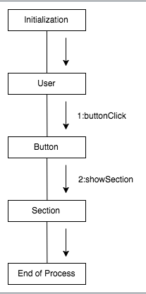

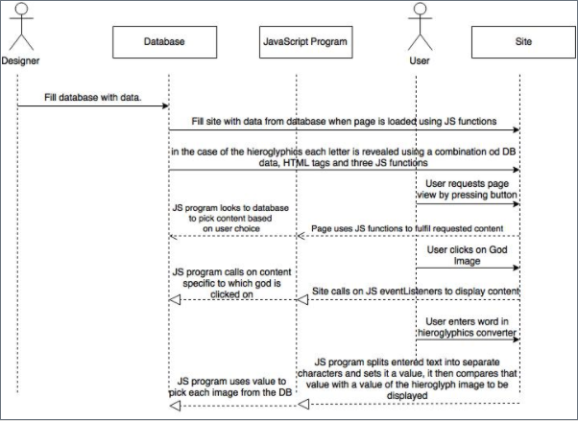

This is a screenshot of a sequence and a collaboration diagram

WEEK 13 - Produce two object diagrams.

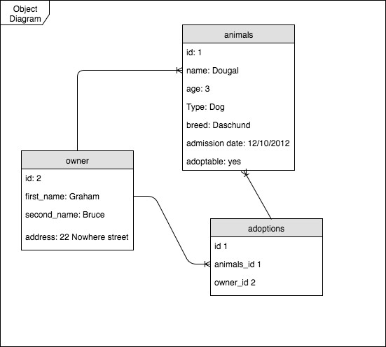

WEEK 13 - Select two algorithms you have written (NOT the group project). Take a screenshot of each and write a short statement on why you have chosen to use those algorithms.

WEEK 13 - Produce a bug tracking report

